**PROJECT REPORT**

**On**

**<AI Bot to play Tic-Tac-Toe >**

***A Project Report Submitted in partial fulfillment for the award of the degree of***

**BACHELOR OF ENGINEERING**

**IN**

**Computer Engineering and Application**

#### Submitted by Submitted to

**Ashutosh Singh-H- 2115000235 Amir Khan**

#### Deepansh Niranjan-I- 2115000324 Asst. Professor

**Suyash Kumar-K-2115001025 (CEA Department)**

**Divyam Upadhyay-I-2115000377**



#### GLA University, Mathura

NOV 2023

#### BONAFIDE CERTIFICATE

Certified that this project report **“AI Bot to play Tic-Tac-Toe”** is the bonafide work of “Ashutosh Singh, Deepansh Niranjan, Suyash Kumar, Divyam Upadhyay” who carried out the project work under my supervision.

|  |  |
| --- | --- |
| **SIGNATURE**  Dr. Rohit Agrawal  **HEAD OF THE DEPARTMENT**  Department of Computer Engineering | **SIGNATURE**  Mr. Amir Khan  **SUPERVISOR**  Asst. professor  CEA Department |

& Application

Submitted for the project viva-voce examination held on

**INTERNAL EXAMINER EXTERNAL EXAMINER**

**ACKNOWLEDGEMENT**

It is my pleasure to be indebted to various people, who directly or indirectly contributed in the development of this work and who influenced our thinking, behavior and acts during the course of study.

We express our sincere gratitude to **Mr. Amir Khan**, for providing us an opportunity to undergo this Project as the part of the curriculum.

We are thankful to **Mr. Amir Khan** for his support, cooperation, and motivation provided to us during the training for constant inspiration, presence and blessings.

We would also like to thank our **H.O.D Mr.Rohit Agarwal** for her valuable suggestions which helps us lot in completion of this project.

We also extend our sincere appreciation to **Mr. Amir Khan** who provided his valuable suggestions and precious time in accomplishing our Project report.

Lastly, we would like to thank the almighty and our parents for their moral support and friends with whom we shared our day-to-day experience and received lots of suggestions that improved our quality of work.

#### Ashutosh Singh -H-2115000235 Deepansh Niranjan-I-2115000324 Suyash Kumar-K-2115001025 Divyam Upadhyay-I-2115000375

#### TABLE OF CONTENTS

**List of Figures Abstract Graphical Abstract Abbrevations**

#### Chapter 1 Introduction

* 1. Identification of relevant Contemporary issue
  2. Identification of Problem
  3. Identification of Tasks
  4. Timeline ‘
  5. Organization of the Report

#### Chapter 2 Goals and Objectives

* 1. Problem Statement
  2. Goals and Objectives

#### Chapter 3 Design Flow

* 1. Hardware & Software Requirements
  2. Project Design

#### Chapter 4 Implementation &Validation

4.1 Implementation

#### Chapter 5 Conclusion and Future Work

* 1. Conclusion
  2. Future Work

**References**

# List of Figures

**Figure 3.1 Interface**

**Figure 3.2 Choosing AI as opponent**

**Figure 3.3 Move 1**

**Figure 3.5 Move2 Figure 3.6 Move 3**

# ABSTRACT

The development of an Artificial Intelligence (AI) Bot to play Tic-Tac-Toe represents a captivating exploration into the realms of computational intelligence and strategic decision-making within the context of a classic and seemingly simplistic game. This project aims to harness the power of advanced AI algorithms to create an interactive and intelligent opponent capable of providing a challenging and engaging gaming experience.

Key components of this AI Bot include a meticulously designed game representation, efficient move generation mechanisms, and a robust evaluation function to guide decision-making. The incorporation of the Minimax algorithm, forms the backbone of the AI's strategic prowess, allowing it to navigate the decision space and make optimal moves.

The project also emphasizes the importance of a user-friendly interface, ensuring a seamless interaction between the player and the AI.

Through systematic testing against diverse opponents and the exploration of scalability options, this project not only aims to create an adept Tic-Tac-Toe player but also lays the groundwork for future applications in the broader landscape of AI gaming. This abstract encapsulates the essence of a project that transcends the boundaries of a classic game, offering insights into the potential and challenges of integrating AI into interactive and strategic gaming scenarios.

**GRAPHICAL ABSTRACT**

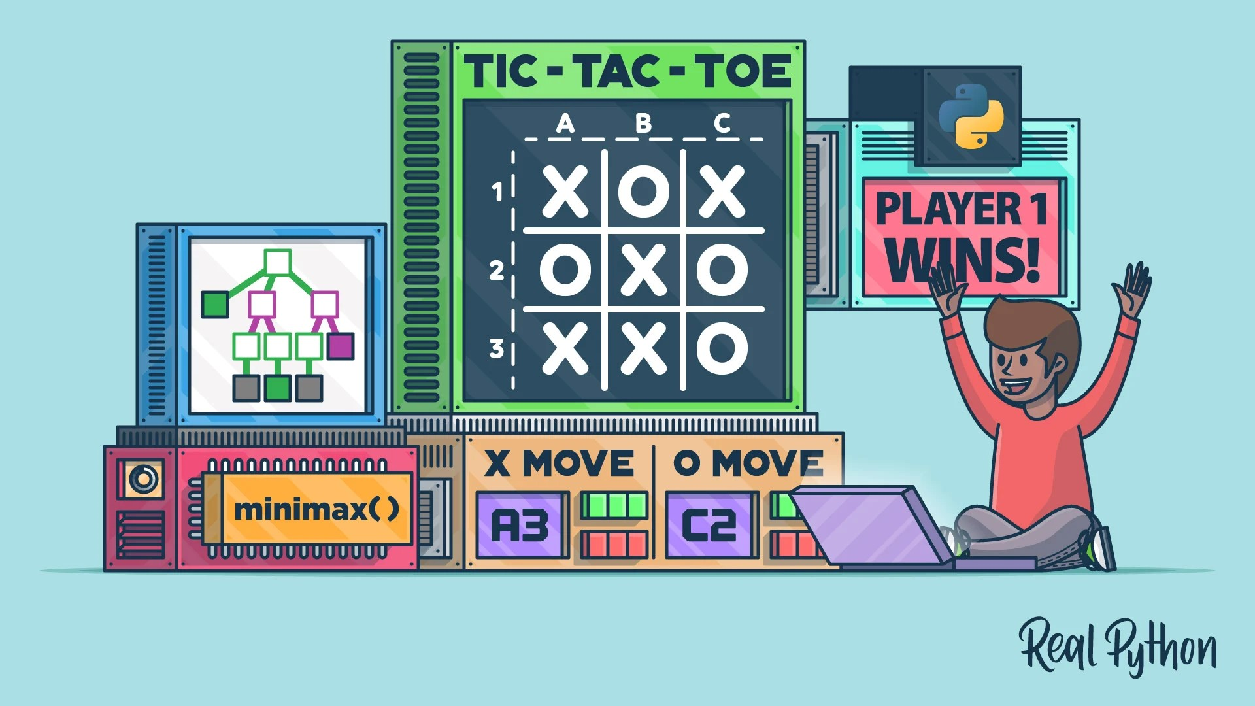

### CHAPTER 1 INTRODUCTION

* 1. **Identification of relevant Contemporary issue**

In creating an AI Bot for Tic-Tac-Toe, it's essential to address ethical concerns like bias, prioritize user experience through intuitive design, ensure security and privacy, optimize technical efficiency, and consider the potential educational and environmental impact. Navigating these issues promotes responsible and inclusive development, enhancing the overall value and acceptance of the AI Bot.

### Identification of Problem

Developing an AI Bot for Tic-Tac-Toe involves addressing challenges such as designing an efficient decision-making algorithm, mitigating biases for ethical gameplay, creating an intuitive user interface, enabling adaptability and learning, ensuring security and privacy, optimizing technical efficiency, and exploring the educational potential of the bot. Balancing these considerations is key to achieving a successful and responsible AI gaming experience.

### Identification of Tasks

1. Develop an intelligent decision-making algorithm like Minimax, ensuring fairness and mitigating biases.

2. Design an intuitive user interface for an engaging gaming experience.

3. Create adaptability mechanisms for the AI Bot to cater to different player skill levels.

4. Implement robust security measures for user data protection.

5. Continuously optimize the AI algorithm for resource efficiency.

6. Integrate educational features into the user interface.

7. Establish a comprehensive testing framework for performance evaluation.

8. Collect player feedback for iterative improvements.

9. Provide transparent documentation on the decision-making process.

10. Implement accessibility features for inclusivity.

11. Consider scalability options for future enhancements.

### Timeline

* Requirements Gathering (Week 1-2)
* Design and Architecture (Week 2-3)
* Development of Tracking System (Week 3-4)
* User Interface Development (Week4-5)

### Organization of the Report

The report is organized comprehensively, presenting clear insights into the project's objectives, scope, methodology, proposed system, features, and implementation plan. It also highlights team members, required resources, references, and expected outcomes. This structured approach ensures a thorough and coherent presentation of the project details.

### CHAPTER 2 GOALS AND OBJECTIVES

* 1. **Problem Statement**

Developing an AI Bot for Tic-Tac-Toe poses challenges in optimizing decision-making efficiency, addressing biases, ensuring an intuitive user interface, adapting to player skill levels, securing user data, optimizing technical performance, integrating educational features, and establishing a robust testing framework. These challenges collectively impact the effectiveness, fairness, and overall user experience of the AI Bot.

### Goals and Objectives

1. Optimal Decision-Making:

- Develop Minimax algorithm for strategic moves.

2. Bias Mitigation and Fairness:

- Identify and address biases for impartial gameplay.

3. Intuitive User Interface:

- Design a user-friendly interface for seamless interaction.

4. Adaptability Across Skill Levels:

- Implement adaptive mechanisms for diverse player experiences.

5. Security and Privacy Assurance:

- Establish robust measures for user data protection.

6. Technical Efficiency:

- Continuously optimize the algorithm for smooth gameplay.

7. Educational Value Integration:

- Include features for insights into AI decision-making.

8. Comprehensive Testing Framework:

- Rigorously test for robust performance against diverse scenarios.

9. Player Feedback Mechanism:

- Collect and implement feedback for iterative improvements.

10. Transparency and Documentation:

- Provide clear documentation on the AI's decision-making.

11. Accessibility Features:

- Implement inclusivity measures for diverse user abilities.

12. Scalability Considerations:

- Explore options for future enhancements and adaptability.

#### CHAPTER 3 DESIGN FLOW

* 1. **Hardware & Software Requirements**
     + Python
     + VS CODE
     + Version Control and Hosting: GitHub
     + Processor: i5 or above
     + Minimum 4GB RAM
     + Windows Operating System

#### Project Design

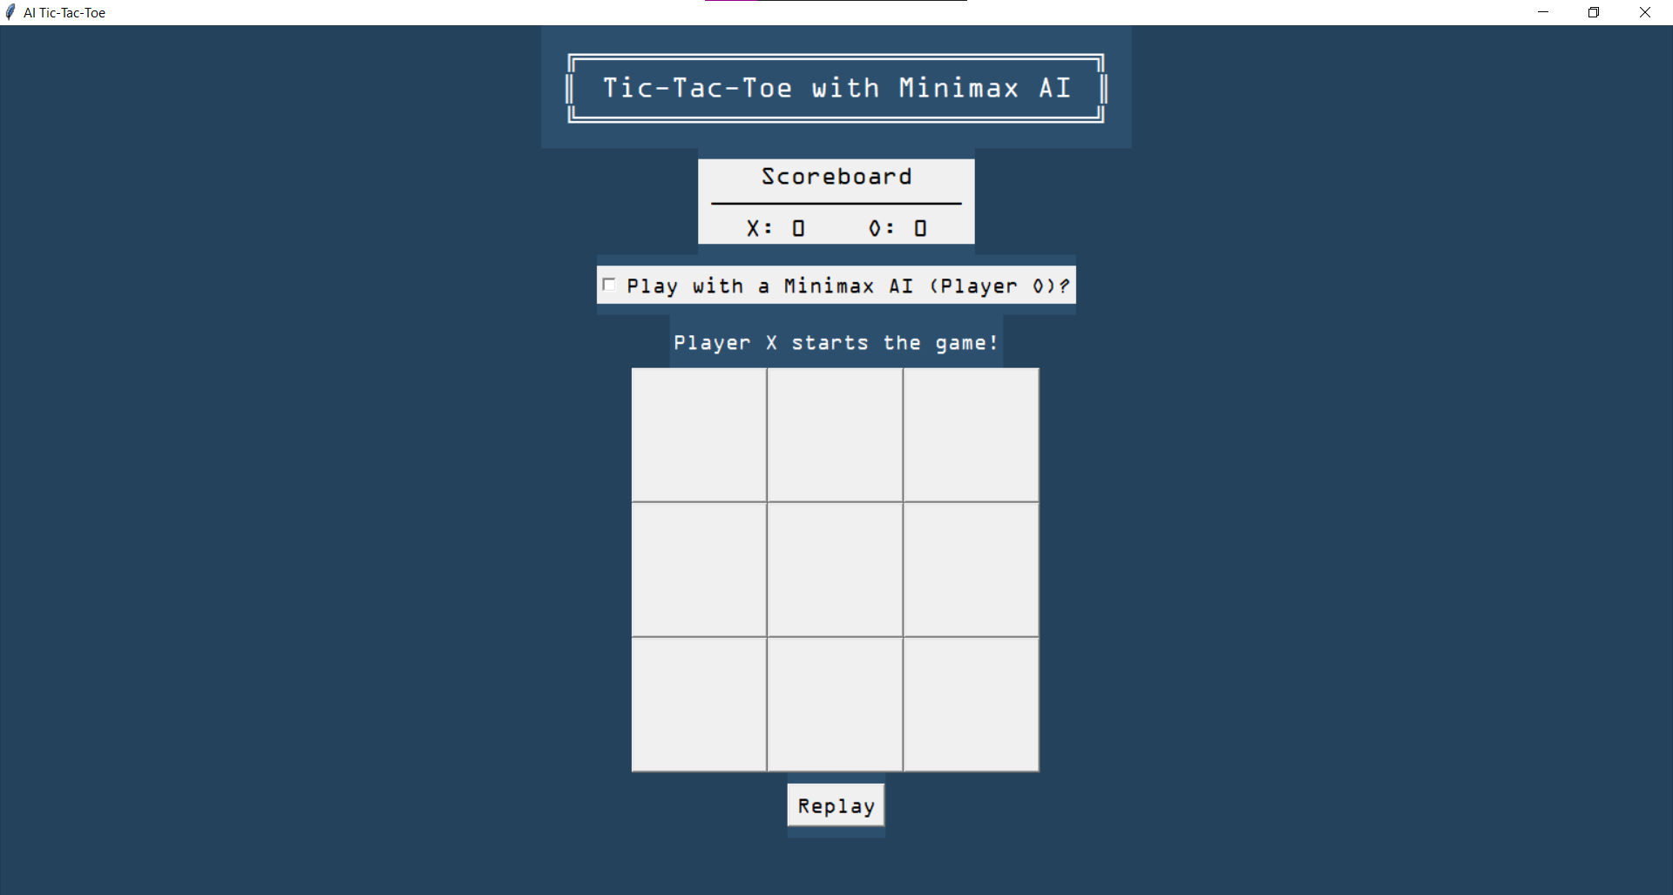

**Figure 3.1** Interface

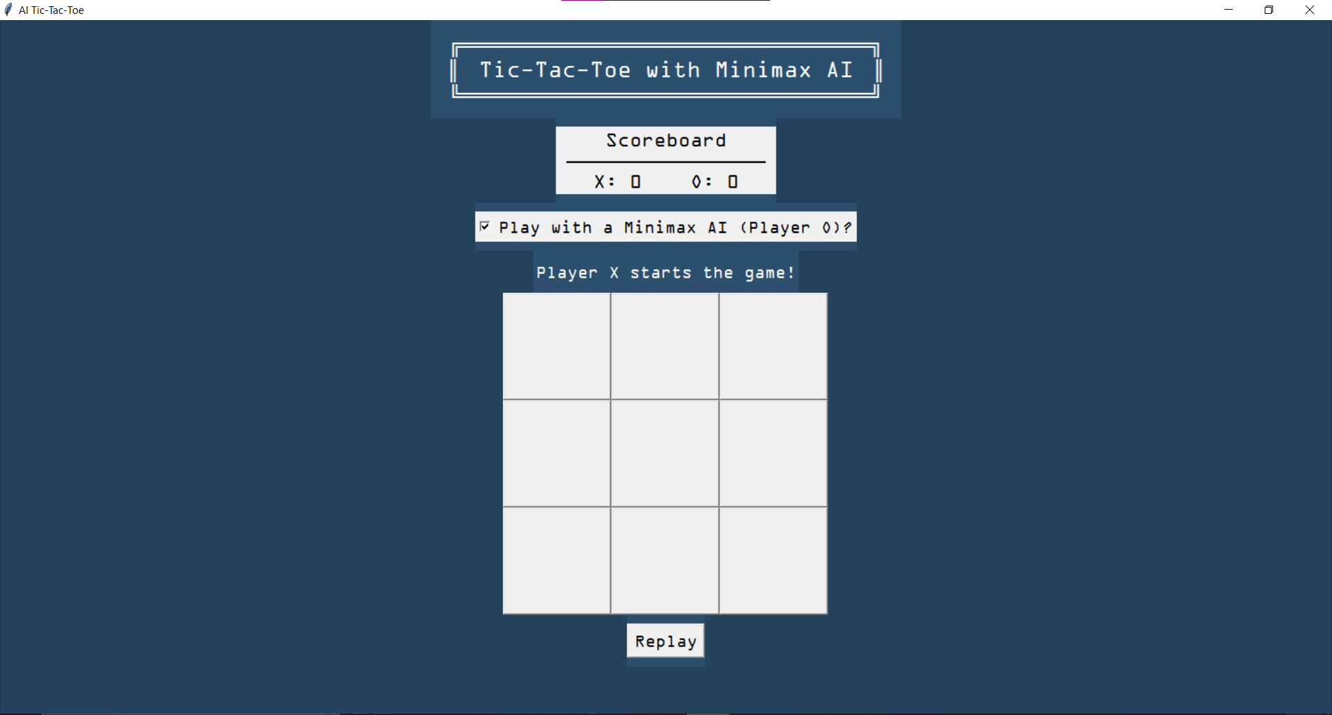

**Figure 3.2** Choosing AI as an opponent

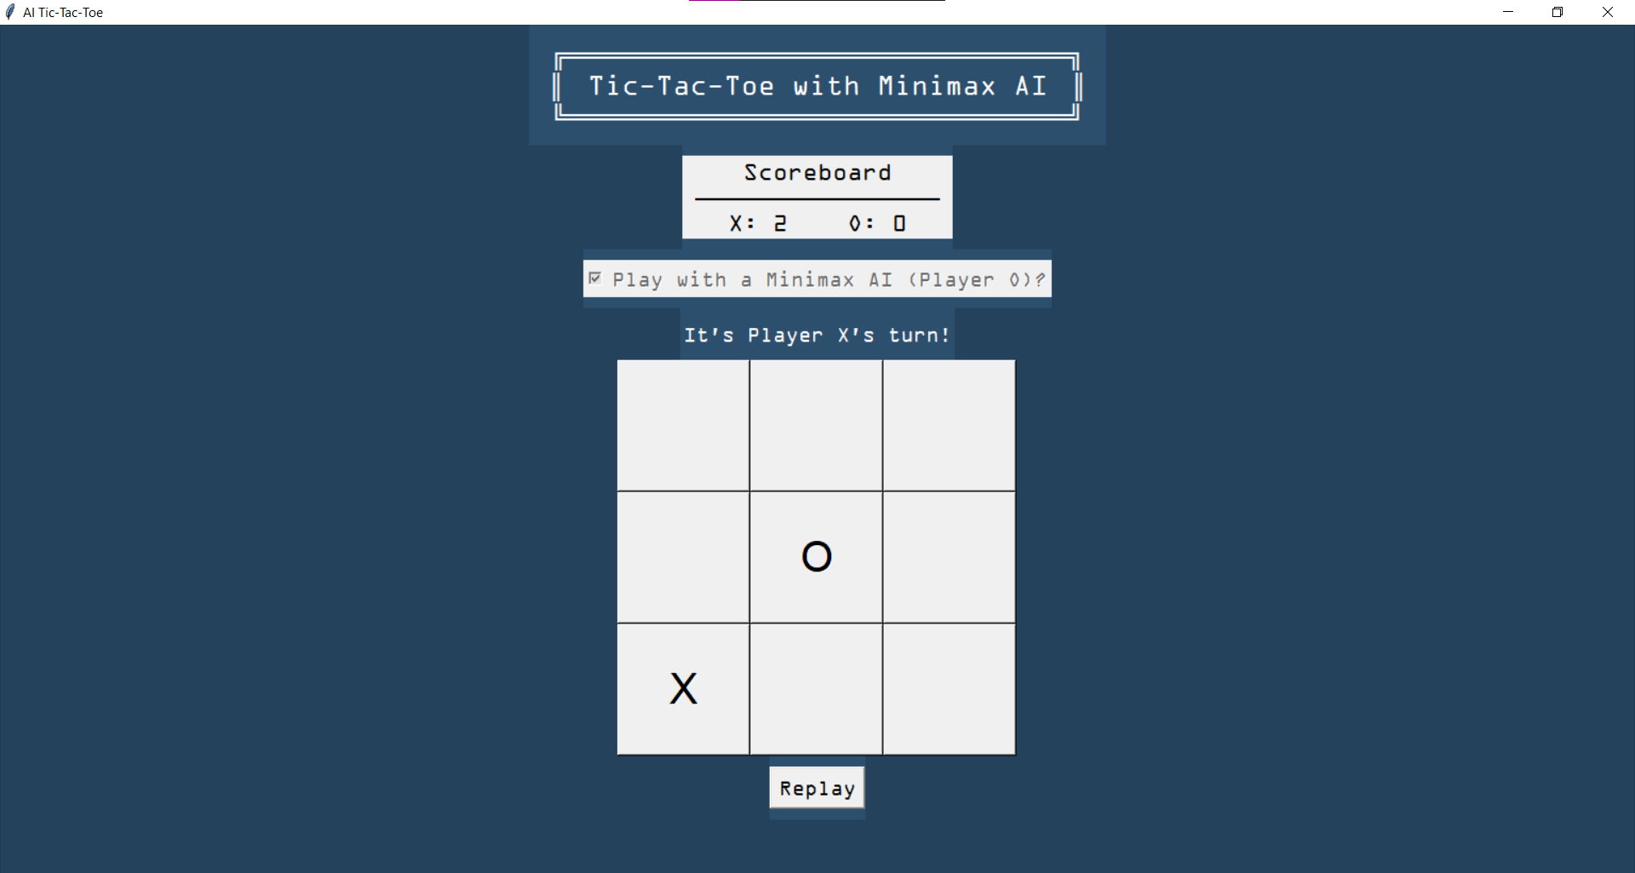

**Figure 3.3** Move 1

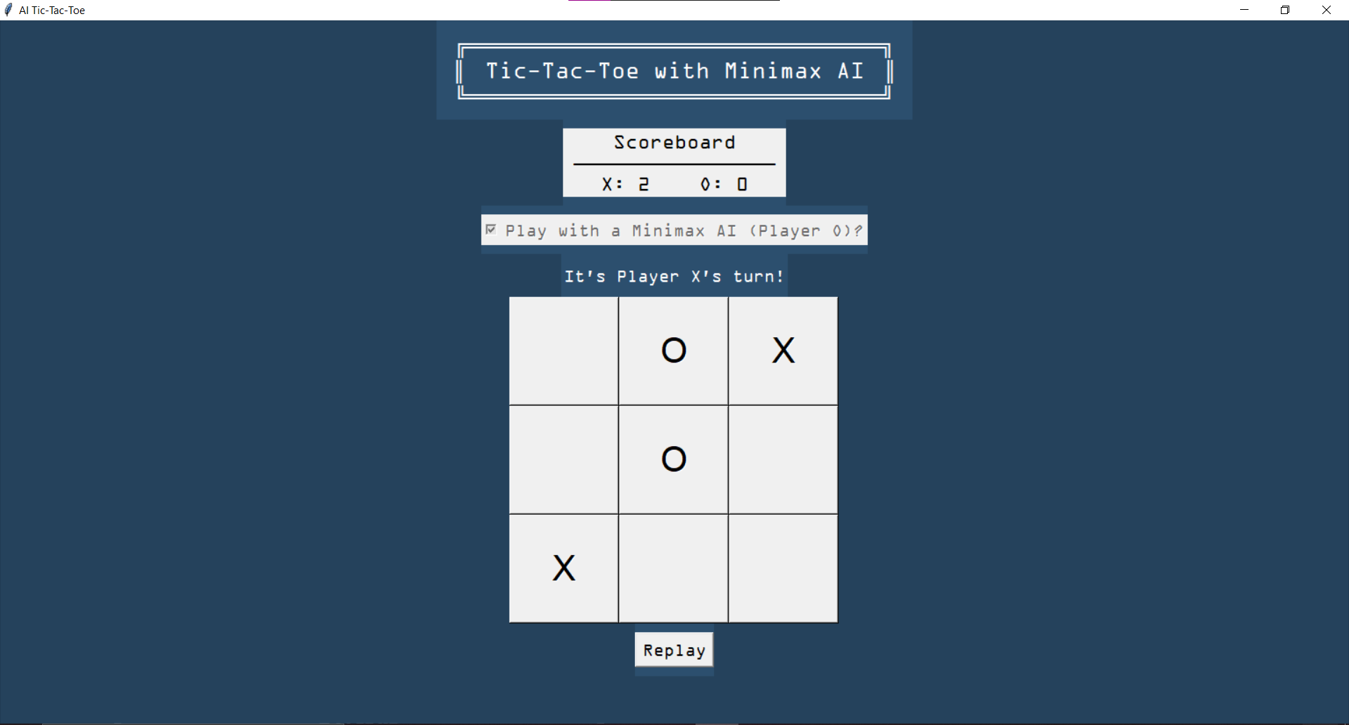

**Figure 3.4** Move 2

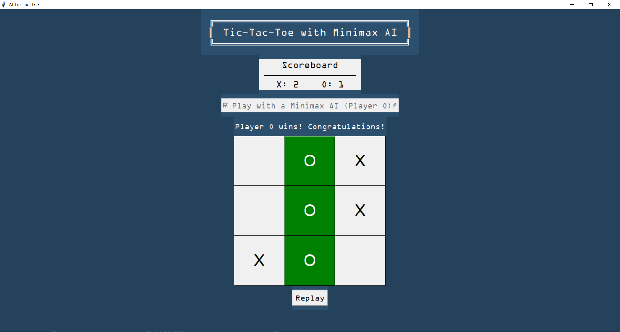

#### CHAPTER 4 IMPLEMENTATION AND VALIDATION

* 1. **Implementation**
* **Minimax Algorithm –**

The Minimax algorithm is a decision-making algorithm commonly used in two-player games to determine the optimal move for a player. In the context of Tic Tac Toe, where the objective is to align three marks (either 'X' or 'O') horizontally, vertically, or diagonally, the Minimax algorithm recursively evaluates possible moves to find the best move for the maximizing player (in this case, 'O', representing the AI), assuming optimal play from both players.

### CONCLUSION AND FUTURE WORK

#### Conclusion

#### In conclusion, the development of an AI Bot to play Tic-Tac-Toe is a multifaceted endeavor that requires meticulous attention to algorithmic intelligence, user experience, and ethical considerations. The project involves creating a decision-making algorithm, addressing biases, designing an intuitive interface, ensuring adaptability, implementing security measures, optimizing efficiency, integrating educational elements, establishing a robust testing framework, collecting user feedback, and ensuring transparency and accessibility.

#### Future work

#### The future scope of AI includes increased automation in various industries, transformative impacts on healthcare, advancements in autonomous vehicles, improved natural language processing, applications in finance and education, enhanced cybersecurity measures, contributions to addressing climate change, improvements in entertainment. Overall, AI is expected to play a pivotal role in shaping the future across diverse sectors of society.

### REFERENCES

* wikipedia.org
* ChatGPT
* Geeksforgeeks.org
* w3schools.com
* github.com
* youtube.com

### APPENDIX

**USER MANUAL**

(Complete step by step instructions along with pictures necessary to run the project)